Ideation Phase

Empathize and Discover
Date | 03 November 2025
Team Id | NM2025TMID02009
Project Name | Streamlining ticket assignment for efficient support operations
Maximum Marks | 4 Marks

Empathize And Discover:

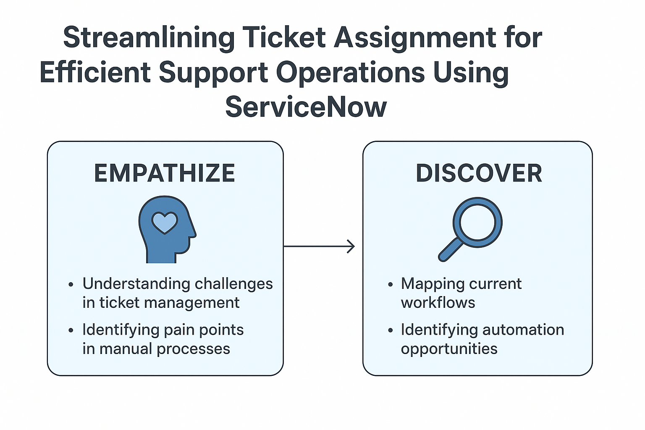

Empathize:
In the initial phase of the project, the primary focus was on understanding the challenges faced by support teams in managing and assigning incoming tickets. Through discussions with support agents, team leads, and IT administrators, it was found that manual ticket assignment often led to delays, uneven workload distribution, and customer dissatisfaction. The team empathized with the frustration of support engineers who faced repetitive manual tasks and the management team struggling to maintain operational efficiency. By observing their daily workflows and collecting feedback, key pain points were identified — including time-consuming manual triage, lack of transparency in ticket prioritization, and the absence of automation to improve response times.

Discover:
During the discovery phase, detailed process mapping and data analysis were carried out to identify gaps in the current ticket management workflow. It was discovered that tickets were often assigned based on limited information, resulting in misrouted or duplicate tickets. The team analyzed existing ServiceNow modules, studied ticket trends, and reviewed assignment patterns to understand areas where automation could bring measurable improvements. Research revealed that implementing an automated ticket assignment system using ServiceNow’s workflow capabilities could significantly enhance efficiency, reduce resolution time, and improve customer satisfaction. Key insights from this phase guided the project’s objective to create a smart, rules-based, and skill-oriented ticket assignment system.

